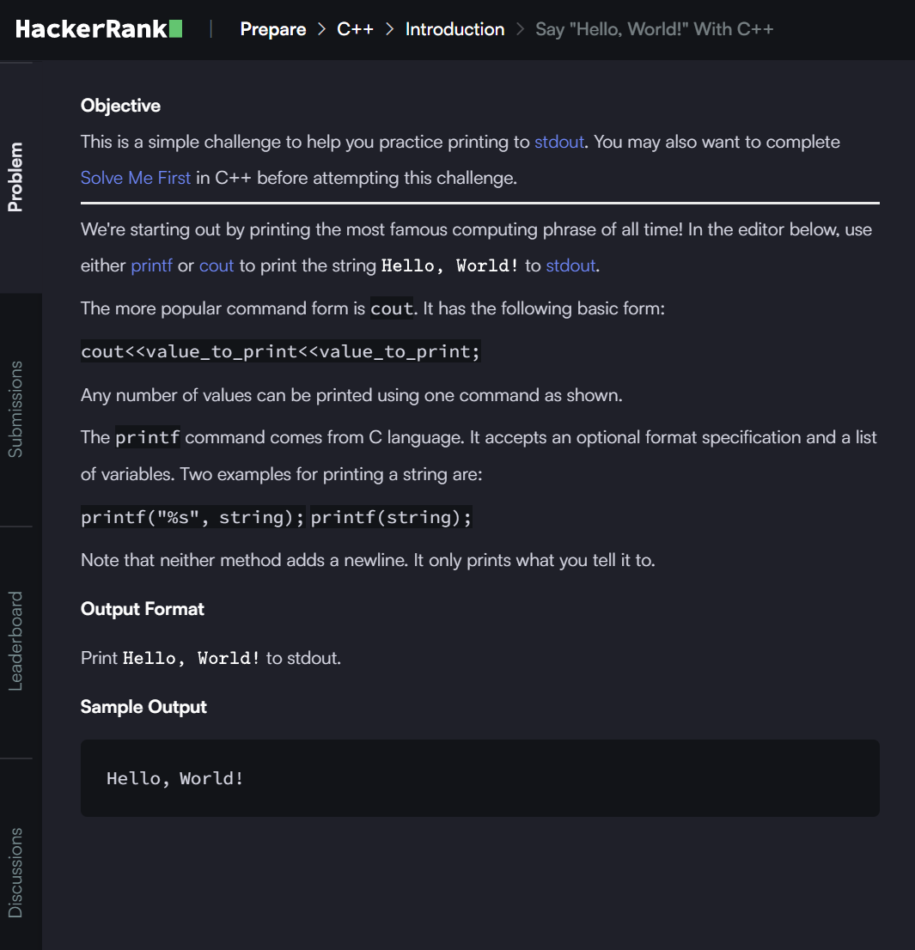

**ANSWER**

#include <iostream>

using namespace std;

int main() {

    cout << "Hello, World!";

    return 0;

}